Notes of the Meeting of
Annual Parish Meeting
at The Memorial Hall, Harmston
on Tuesday 20th May 2025 at 7.00 pm

Present:
Parish Councillors: Cllr P Wallace, Cllr B Hamilton, Cllr P Chapman, Cllr B Smith and HPC Clerk & RFO Mrs Helen Jones
District Councillor Cooper
County Councillor Carrington
Representatives from local groups: R Wheeler (Harmston Church); Helen Robertson (HMH)
There were no members of the public present

Item 1 - APOLOGIES
Apologies were received from WI, Coleby C of E School, Harmston Young Farmers, Parish Councillor Harrison, District Councillor Pennell & Sanders and PC Roberts

Item 2 - Police Report
PC Roberts was unable to attend.

Item 3 – Minutes of Last Meeting (held in 2024)
The minutes from 2024 were approved by those who were in attendance at that meeting, and signed by Paul Wallace.

Item 4 – County & District Councillors
- County Councillor Report Cllr Carrington explained it has been a successful year for Lincolnshire County Council, Outstanding Ofsted for children’s services. There has been an impact of floods on other parts of the parish. Working on becoming more flood resistant. Election has seen a new administration – with a Reform majority. North Hykeham Relief Road has been reassured that the government is committed to funding.
Re lorries through village – those HGV vehicles associated with LCC now cannot cut through Harmston (or most A-roads in the county) as part of their contract. This will reduce County Council lorry travel through Harmston – apart through emergency reasons.
Regarding BESS (Coleby) – this will be decided in NKDC by the planning committee Travel plan would mean all materials would go through Harmston. There is an aim to have this changed if the BESS is approved.

- District Councillor Reports
Cllr Cooper * Appendices 1
Cllr Pennell *Appendices 2
Item 5 – Village Interests and Activities

8 different groups were invited to share reports. Reports were received from 6 of these groups, with representatives attending the meeting to share them as follows:
- Rob Wheeler on behalf of Harmston Church
Works have begun on the church tower, after 10 years of planning. Thanks to HPC for their financial contributions. Scaffolding going up this week. Working hard on using the correct stone. Work should take 3 months. The church will remain open during the works.
There is still no new Vicar, but services continue in normal pattern.
Have been looking for volunteers for grass cutting for past 3 months.

- The Clerk read a report on behalf of Coleby Primary School*Appendices 3

- The Clerk read a report on behalf of Harmston WI *Appendices

- H Robertson on behalf of Harmston Memorial Hall
Thanks to the helpers – who keep the hall running for all. Lots of events throughout the year – something for all ages, New big screen is now in use. Attendance is so importance – as this helps raise funds. Thanks to our regular hirers. Thanks to Shep for his monthly quiz – lots of charities have been helped.
Money has been raised for the new floor, which needs replacing at a cost of £50,000. Gained a grant and had also many donations. Have now raised £51,000 and are ready to start works. We have also had a serious leak – losing gallons of water daily. All now repaired and covered by insurance.
Huge thank you to the Harmston Memorial Team.

- The Clerk read a report on behalf of Harmston Young Farmers *Appendices 5

- Cllr P Wallace on behalf of Harmston Parish Council *Appendices 6
These reports have been kept on file, and are attached as appendices.

Item 6 – Residents issues, an open forum
None were received ahead of the meeting.
The issue of weeds was raised. The PC have a quote ready to be approved at their meeting (which follows this APM).
Cllr Cooper passed on his thanks to the hall and their catalogue of events. The PC agreed fully with this.
HPC Chair explained that the planning application for the BESS in Coleby was not received until after the HPC’s agenda had been published. Therefore, an extraordinary meeting would be called so that a response could be drafted and submitted. ACTION: Clerk schedule Extraordinary Meeting.

With there being no further business, the meeting was brought to a close at 8.03pm.

*Appendices 1

Report from District Councillor Cooper for 2024-2025

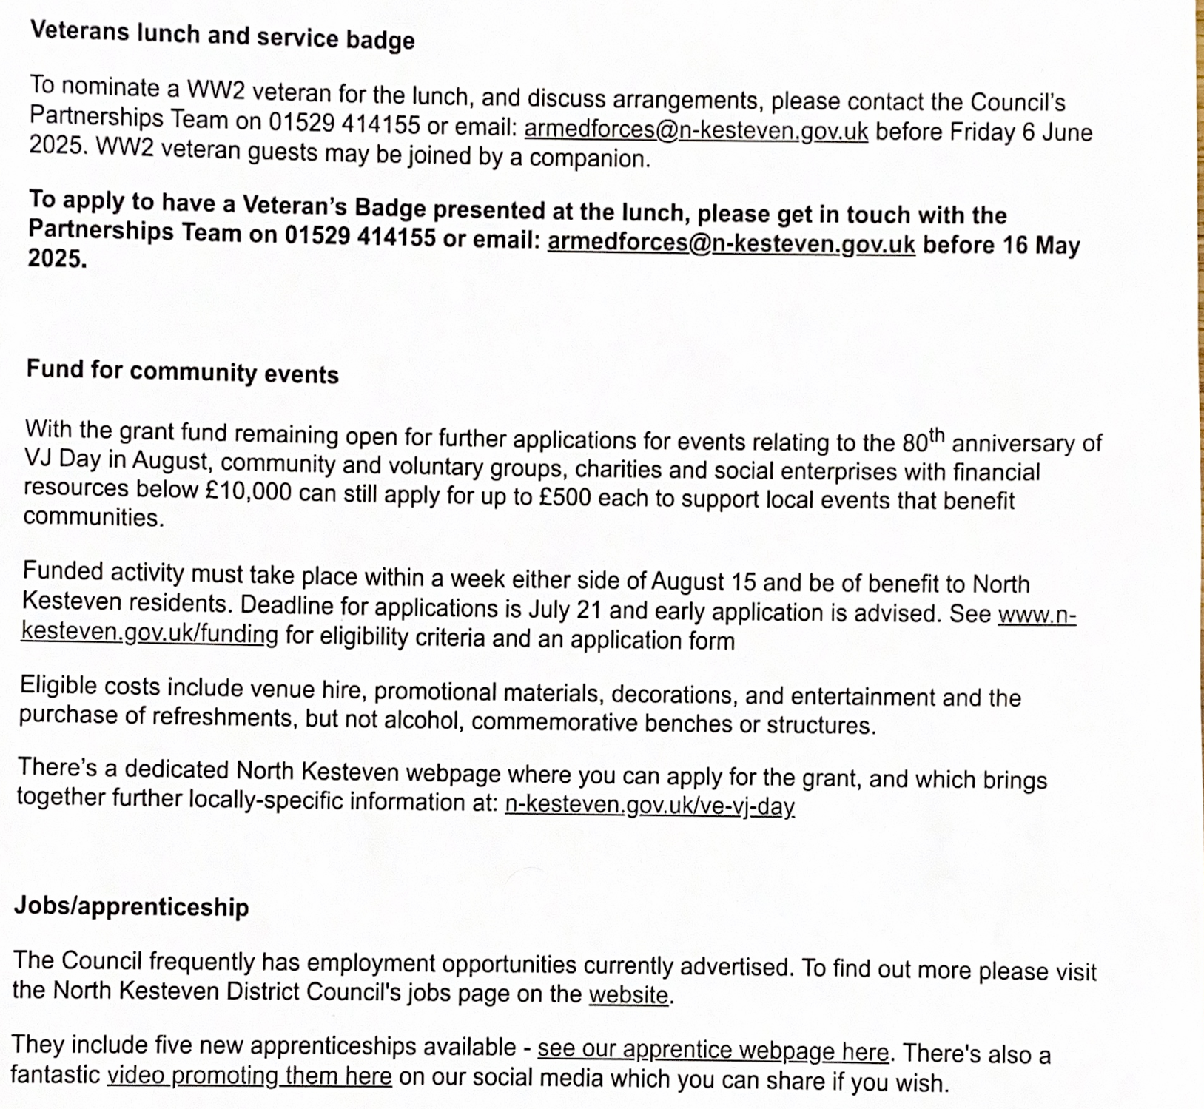

*Appendices 2

Report from District Councillor Pennell for 2024-2025

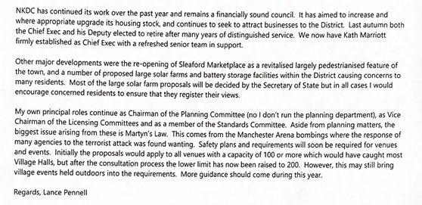

*Appendices 3

Report from Coleby CofE Primary School for 2024-2025

School Updates
School life continues to be very busy, with lots of learning and exciting things taking place.
Currently there are 46 children on role at the school, we are hopeful that this number will rise in the near future.
The application for Coleby school to become an academy and join Infinity Academies Trust has been successful and this will formally take place on 1st September 2025. The trust have been supporting the school this academic year and will continue to do so. With the move to academy status, the school will share a headteacher with Leadenham school and this will be Mr John Slater. John, has been working at Coleby already, taking a lead on teaching and learning and he will continue to increase his time at Coleby over the coming weeks. This is an exciting time for the school and a move to join the trust will help secure the long-term future of the school and hopefully see pupil numbers increase.
The planned works on the boundary wall have again been delayed, it is our understanding that this is now back with the Local Authority for next steps. As soon as we have a confirmed date for this we will let you know.
Over the coming weeks/months there will be work taking place to improve the school environment which includes:
- New LED lighting throughout the school
- New flooring in the school hall
- Refurbished toilets for the children
- Electronic sign in system installed
We have recently updated our school vision and values, which are now:
“With God all Things are Possible.”
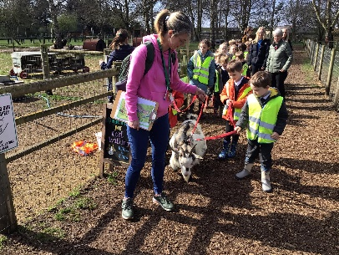

School Updates
Last term we had two school trips take place. Class 1 visited Tattershall Farm Park and KS2 visited the Holocaust Memorial Centre in Laxton. Both trips were thoroughly enjoyed by all of the children and we are grateful to the staff who helped arrange them.

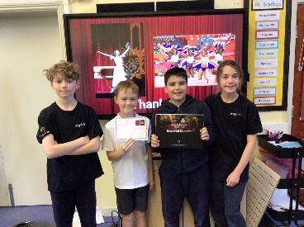
We continue our partnership with Inspire+, who are a local sports charity. Earlier this week Paige from inspire+ came in and assisted our young ambassadors in delivering their very own legacy tour assembly. The school will be taking part in the mini-Olympics in the summer, and they will be representing New Zealand

The school year is flying by, and the coming weeks promise to be very busy with statutory assessments taking place across a number of year groups as well as a residential visit and numerous other events.

*Appendices 4

Report from Harmston WI for 2024-2025
Pauline Walker continued as our President for another year. The committee saw Meryl Wakeling stand down after making a massive contribution to the committee during her time in this role. Lorraine Burrows was also co-opted onto the committee in September whilst the rest of the committee remained the same and we established a membership of 34 ladies which is an increase of 2 on last year.
We’ve had some fantastic and varied talks and demonstrations this year organised by Jess, with lots of great trips arranged by Sue.
April started our year with a talk titled Oprah Winfrey Touched My Elbow by Graham Keal who entertained us with his brushes with celebrities. He had us all laughing and raising an eyebrow with some of his tales.
May had us all totally absorbed learning about the Dickin’s medal with a talk from Kenneth Moore and slide show depicting some heroic animals. In fact the awards have gone to 38 dogs, 32 pigeons, 4 horses and a cat!
In June we had a spellbinding talk on witchcraft and shared some delicious bakes for the competition and Pauline attended the Presidents reception at the showground the evening before The Lincolnshire Show.
July was a real hands on event where we had an evening making our own 2 and 3 tier cake stands from preloved plates.
August was our annual garden party in Harmston. The weather was amazing and we even had to put up emergency gazebos to give us extra shade.
September gave us the opportunity to discover how our backs can be key to a lot of our other pain related issues and made us think about how important it is to get it checked out just like we would our sight or hearing.
October was Members Take Over night and I think everyone that attended had great fun and it took us back to our childhood party days.
November saw a craft evening with everyone making a fused glass Christmas tree. It was a great night and there were several disappointed members who couldn’t attend so maybe a future revisit will be needed.
December was party time and everyone came together for an evening of entertainment from the Steam Punk Choir whilst enjoying great food and company in a festive setting.
January was a change to the schedule as the pasta lady postponed but what an excellent evening it turned out to be with everyone thoroughly enjoying a time to chat and catch up as the new year began with a social evening of decoupage which Cath and Jess prepped for the night before and ran expertly.
Our last talk for the WI year was February with the Inspector Hopkin’s Discovery which was a murder mystery style talk.
The trips and outings have been excellent again with so much opportunity for members to attend social events from bowling, afternoon tea, ghost walk, kinema film ‘What We Did On Our Holiday’ followed by a meal out, Springfields and Merry Makers Market to name a few.
It’s been a busy year as our WI Extras took off enabling members to join in with extra activities of craft, quizzing, coffee morning, walking and reading. We’ve had a great year of fund-raising too lead by Cath through fairs and raffles to raise money for our chosen charity The Lincs and Notts Air Ambulance and presented a cheque for £1,200.00.
We also awarded a certificate to one of our ladies who came as a guest to the garden party as due to relocation she could no longer be a member but had been in WI’s around the country for 60 plus years but spent the majority of those in Harmston.
Finally it goes without saying that the success of Harmston WI is down to the effort that everyone puts in to support its smooth running, whether that’s on the committee or being a member and helping with the monthly cake rota, offering lifts, attending the activities and talks that are put on and entering competitions, setting up the chairs and tables at the start of the meetings or supporting in the kitchen at the end of the night.

*Appendices 5

Report from Harmston Young Farmers for 2024-2025

I would like to start by apologising – I cannot attend as we are very busy currently with our trailer building for Lincs Show, with this year’s theme being Harmston’s Old Train Station.
We as a club would like to thank Harmston Memorial Hall and Harmston for their continued support and allowing us to use the hall. Because of this we have had a very successful Young Farmers year, most notable raising over £10,000 for 4 different charities all close to our hearts.
We have also just placed second in the county at our County Rally and third in the county for Club of the Year. Our Junior Tug of War team have also placed first and we are advancing to the next round!
None of this would be possible without the memorial Hall and we are grateful that we have access to it.

Kimberley Atkin, Chair of HYF

*Appendices 6
Report from Harmston Parish Council for 2024-2025
Communication
- We continue to ensure we utilise a range of methods of communication – to appeal to our wide range of residents, and have reviewed our methods again this year – adding another outlet
- Website regularly updated and used – a great way for everyone to keep in touch – and where we store a range of documents and information for residents to access easily. This has been reviewed this year with additional sections added to enable residents to get a full picture of the workings of their Parish Council
- Facebook regularly used to share information
- Regular articles submitted to Graffoe Link and Harmston Matters, and we have also started submitting monthly articles to Heathcliff View – with the focus of reaching residents who don’t use the internet
- Noticeboard on Harmston Park Avenue has been repaired and repainted this year, and a new sign has been ordered. This, and the High Street board are regularly updated
- We now share our meeting dates on the Harmston Memorial Hall noticeboard for hirers
- We continue to forge good links with local Police, District Councillor and County Councillors

Financial Contributions
- £2,000 was donated towards the new floor at Harmston Memorial Hall
- A contribution has been given to the Salvation Army for their part in our Christmas event (for which they do not charge a fee).
- A £250.00 was contributed to the Church towards grass cutting

Finances
- VAT refund for 2024-2025 for a total of £622.78 has been processed and received
- PC applied for a grant towards litter picking and have received £141.00 again this year towards these costs
- AGAR has been completed for this year
- Annual audit has been carried out for years ending 2024-2025 and have been passed
- Budgets have been set for this year
- Precept has been set – being mindful of the cost of living crisis
- A savings account is being set up for reserve funds

Traffic
- SpID device bought last year is still in constant use on Church Lane (switched with Vicarage Lane when needed). New batteries bought
- The PC remain part of the shared scheme, and use this device on Vicarage Lane. This is currently in use by Welbourn Parish Council
- We continue to use the SpIDs to help inform and guide decisions made for traffic calming

Village Maintenance
- Our Litter Picker continues to do an excellent job – for which we are very grateful
- New lights fitted on School Lane – as the previous one had been damaged
- Defibrillator has been checked and spare pads added
- Handyman has carried out works on areas such as the play area, bus shelters & noticeboards
- Light to be reinstated on Chapel Lane – currently being organised
- Research into correlation between lights being turned off at night and thefts over Christmas on Thorold Way and Crescent Mews

Play Area
- Regular safety inspections carried out by a specialist firm
- Lawns cut regularly
- Handyman fixed fence and carried out equipment repairs
- New sign added at entrance

Events
- Christmas Event was well attended, with the Salvation Army band in attendance

Councillors
- We still have 2 vacancies, please see the Clerk if you would like further details and would like to be involved with decisions being made for our community

